**TIME SERIES SNAPSHOTS**

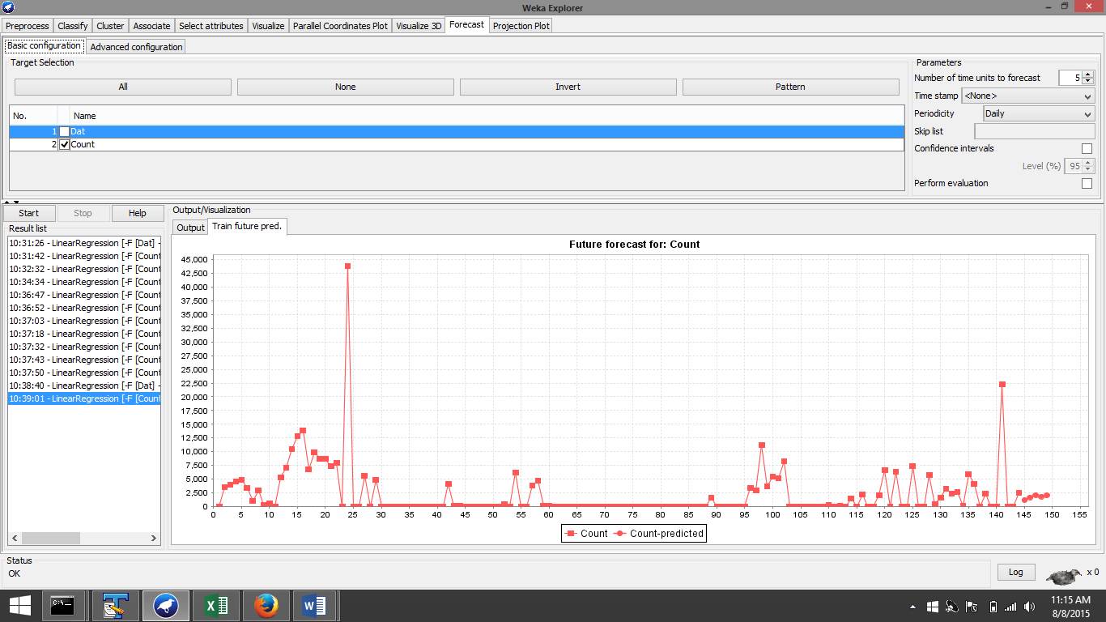

Count is the parameter in linear regression

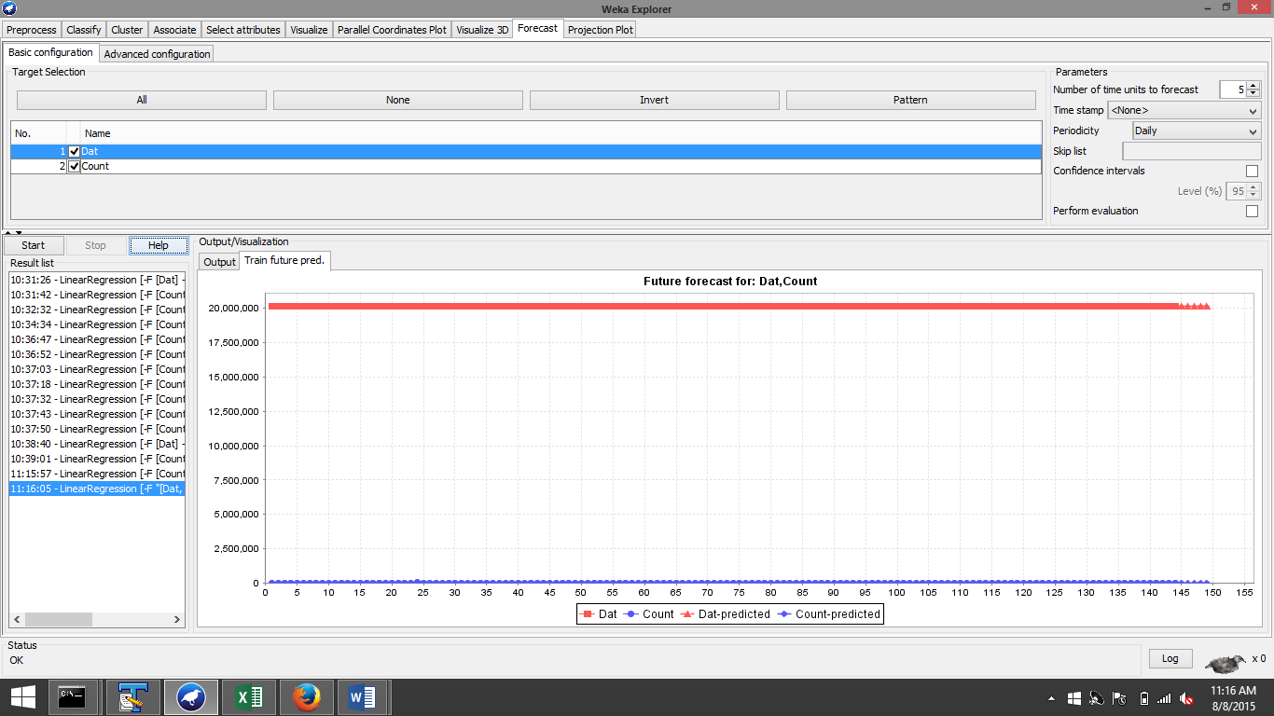

Count and Date becomes the combined predictor variables